UNIVERSITY INSTITUTE OF COMPUTING

PROJECT REPORT

Student Report Card Management System

Program Name: BCA(Data Science)
Subject Name/Code:24CAH-201

Submitted by: Submitted to:
Name: Veena Name:Ms. Shuchi Sharma
UID: 24BCD10048 Designation:
Section: 24BCD-1A

Project Report: Student Report Card Management System

Aim of the Project:

The aim of this project is to design a simple C++ program that can store student details, calculate total marks, average, and grade, and display the report card for each student.
2. Objective:
- To understand and apply Object-Oriented Programming concepts such as inheritance, encapsulation, and polymorphism.
- To create a simple system that can store and manage student data easily.
- To calculate the total marks, average, and grade of each student automatically.
- To demonstrate code reusability and data abstraction in a practical project.
3. Tools and Technologies Used:
- Programming Language: C++
- Compiler: Turbo C++ / Visual Studio Code
- Operating System: Windows (any version)
- Concepts Used:
- Classes and Objects
- Inheritance
- Constructor Overloading
- Encapsulation
- Polymorphism
- Conditional Statements and Loops.

Algorithm / Logic:
- Start the program.
- Create a base class Student to store basic details like name and roll number.
- Create a derived class Marks from Student to store marks of three subjects.
- Create another derived class Grade from Marks to calculate total marks, average, and grade.

- Use constructors to initialize data for each student.
- Use functions to calculate total marks and average.
- Apply conditional statements to assign grades (A, B, C, F) based on average marks.
- Use menu-driven options to:
- Display all student reports
- Search for a student by roll number
- Find the class topper
- Display the result using function overriding (polymorphism).
- End the program.

Code Overview:

Main Classes:
- Student Class:
Stores name and roll number. Demonstrates encapsulation and constructor overloading.
- Marks Class:
Inherits from Student and adds marks of three subjects. Demonstrates single inheritance.
- Grade Class:
Inherits from Marks and calculates grade based on average marks. Demonstrates multi-level inheritance and polymorphism.

Key Functions:
- totalMarks() → Returns the sum of all marks.
- average() → Calculates average marks.
- display() → Displays student report (overridden in each class).
- findTopper() → Finds student with highest total marks.
- searchStudent() → Searches student by roll number.

- Code:
#include <iostream>
using namespace std;

// Base Class: Student
class Student {

protected:
string name;
int rollNo;

public:

// Constructor overloading
Student() {
name = "Unknown";
rollNo = 0;
}

Student(string n, int r) {
name = n;
rollNo = r;
}

virtual void display() {
cout << "Name: " << name << endl;
cout << "Roll No: " << rollNo << endl;
}

string getName() {

return name;
}

int getRoll() {
return rollNo;
}
};

// Derived Class: Marks
class Marks : public Student {
protected:
int m1, m2, m3;

public:
Marks() : Student() {

m1 = m2 = m3 = 0;
}

Marks(string n, int r, int a, int b, int c) : Student(n, r) {
m1 = a;
m2 = b;
m3 = c;
}

int totalMarks() {
return m1 + m2 + m3;
}

float average() {

return totalMarks() / 3.0;
}

void display() override {
cout << "\n--- Student Report ---" << endl;
Student::display();
cout << "Marks: " << m1 << ", " << m2 << ", " << m3 << endl;
cout << "Total: " << totalMarks() << endl;
cout << "Average: " << average() << endl;

}
};

// Derived Class: Grade
class Grade : public Marks {
char grade;

public:
Grade() : Marks() {

grade = 'F';
}

Grade(string n, int r, int a, int b, int c) : Marks(n, r, a, b, c) {
float avg = average();
if (avg >= 90)
grade = 'A';
else if (avg >= 75)
grade = 'B';
else if (avg >= 50)
grade = 'C';

else
grade = 'F';
}

char getGrade() {
return grade;
}

void display() override {
Marks::display();

cout << "Grade: " << grade << endl;
}
};

// Function to find the topper
void findTopper(Grade *students[], int n) {
int maxMarks = -1, index = -1;
for (int i = 0; i < n; i++) {
int total = students[i]->totalMarks();
if (total > maxMarks) {
maxMarks = total;

index = i;
}
}

if (index != -1) {
cout << "\n Topper of the Class " << endl;
students[index]->display();
}

}

// Function to search student by roll number
void searchStudent(Grade *students[], int n, int roll) {
for (int i = 0; i < n; i++) {
if (students[i]->getRoll() == roll) {
cout << "\nStudent Found!" << endl;
students[i]->display();
return;
}
}

cout << "No student found with Roll No: " << roll << endl;
}

// Main function
int main() {
int n, choice;
cout << "Enter number of students: ";
cin >> n;

Grade *students[n];

for (int i = 0; i < n; i++) {

string name;

int roll, m1, m2, m3;
cout << "\nEnter details for student " << i + 1 << endl;
cout << "Name: ";
cin >> name;

cout << "Roll No: ";
cin >> roll;
cout << "Enter marks in 3 subjects: ";
cin >> m1 >> m2 >> m3;

students[i] = new Grade(name, roll, m1, m2, m3);
}

do {
cout << "\n===== STUDENT REPORT CARD SYSTEM =====" << endl;
cout << "1. Display All Reports" << endl;
cout << "2. Search Student by Roll No" << endl;

cout << "3. Show Class Topper" << endl;
cout << "4. Exit" << endl;
cout << "Enter your choice: ";
cin >> choice;

switch (choice) {
case 1:
cout << "\n===== ALL STUDENT REPORTS =====" << endl;
for (int i = 0; i < n; i++) {
students[i]->display();
}
break;

case 2: {

int roll;

cout << "Enter Roll No to search: ";

cin >> roll;
searchStudent(students, n, roll);
break;
}

case 3:
findTopper(students, n);
break;

case 4:
cout << "Exiting Program. Thank you!" << endl;
break;

default:
cout << "Invalid choice. Try again." << endl;
}

} while (choice != 4);

return 0;
}

Screenshots/ Output

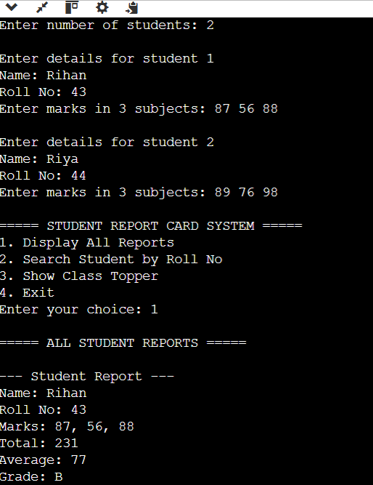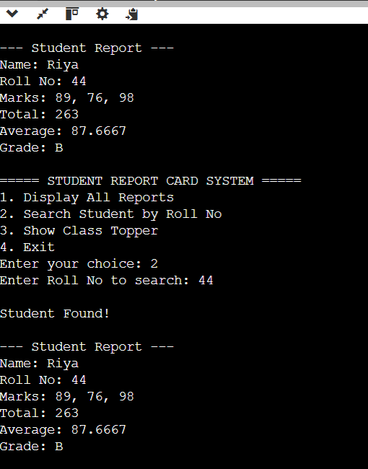

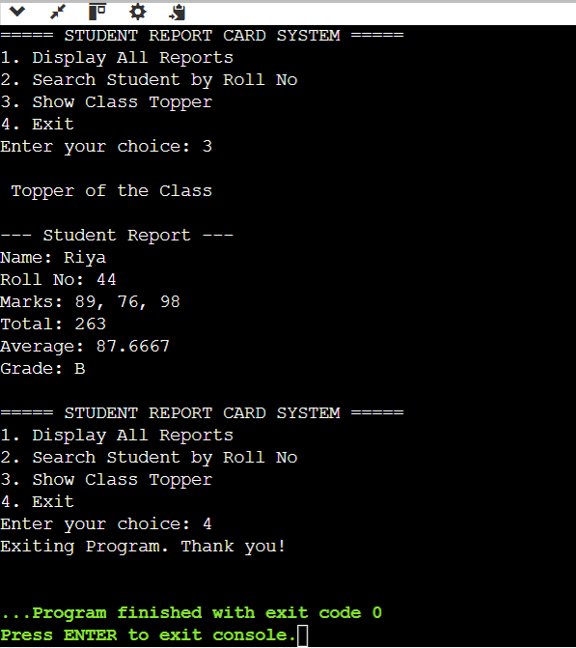

Conclusion:

This project successfully demonstrates how Object-Oriented Programming concepts can be applied to solve real-life problems like managing student records.
It shows how inheritance and polymorphism make the code organized, reusable, and easy to maintain.
The project is simple but clearly represents how data can be structured, processed, and displayed in a user-friendly way.
9. Learning Outcomes:
- To design and implement classes and objects in C++.
- To use inheritance to extend the properties of a base class.
- To apply constructor overloading and function overriding.
- To use encapsulation and data abstraction effectively.
- To build a menu-driven program for interactive use.
- How OOP concepts help in building modular and reusable code.
10. References:
- Online C++ tutorials – www.programiz.com/cpp-programming
- Notes and examples from classroom lectures and lab sessions.

